**Projet Gl - 2eme tache**

**Touati amine G1**

**Guebli Ayoub Abdessami G1**

**Ababsa aymen G1**

**Cicle de vie:**

| **Use Case** | **Priority** | **Risk** |
| --- | --- | --- |
| Add students notes | **medium** | **Low** |
| Consult tests and exercises | **medium** | **Low** |
| View how many time children is absent | **high** | **Low** |
| Add students and teachers to the system | **high** | **Low** |
| Contact and chat with teachers | **medium** | **Low** |
| Add points sheets and school documents | **high** | **Low** |

**Fiche d’escriptive et Diagramme de Sequences :**

**Add notes to the students**

| **Case name** | Add notes to the students |
| --- | --- |
| **type** | Primary |
| **actors** | Teaches |
| **objective** | Add notes and tests note |
| **pre-condition** | Must be authenticated |
| **nominal scenario** | * Teacher click button “show my classes” * The system shows a list of classes taught by the teacher * The teacher click at the class to consult the students * System show the students at that class * Teacher search for a student by firstname and lastname * The system show student study information * Teacher add notes or test points for the student * Teacher click button “save” * The system saved |
| **alternative scenarios** | A1) System can’t found the student  -System noted that the student doesn’t exist in the data base |
| **exception scenarios** | System can’t found the student  Show error message |
| **post-condition** | Note add by the teacher |

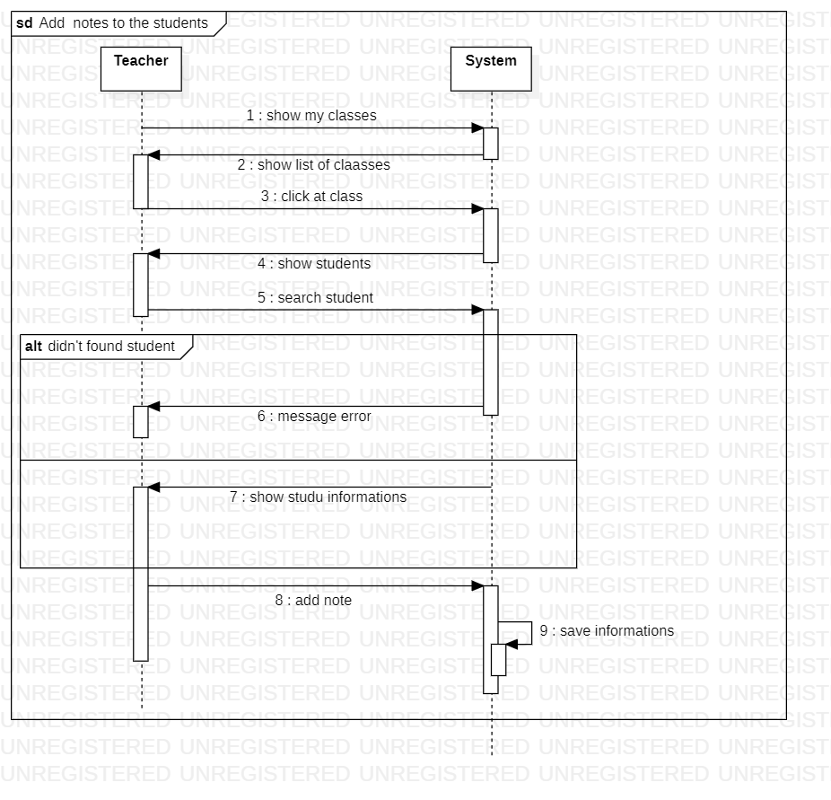

**Consult tests and exercises**

| **Case name** | Consult exercises and tests |
| --- | --- |
| **type** | Primary |
| **actors** | Parents |
| **objective** | Parents consult tests and exercises of their children |
| **pre-condition** | Must be authenticated |
| **nominal scenario** | * Go to “Consult activities” * Choose “my children study” * The system displays list of children * The parent choose one of them * Parent click “show exercises” * System show list of tests * Parent click at the test * Parent consult test and he can download it |
| **alternative scenarios** | * A1) Parent click “show exercises”   -System can’t found any exercises |
| **exception scenarios** | System show error message “we will add exercises soon” |
| **post-condition** | Parent consult exercises of their children |

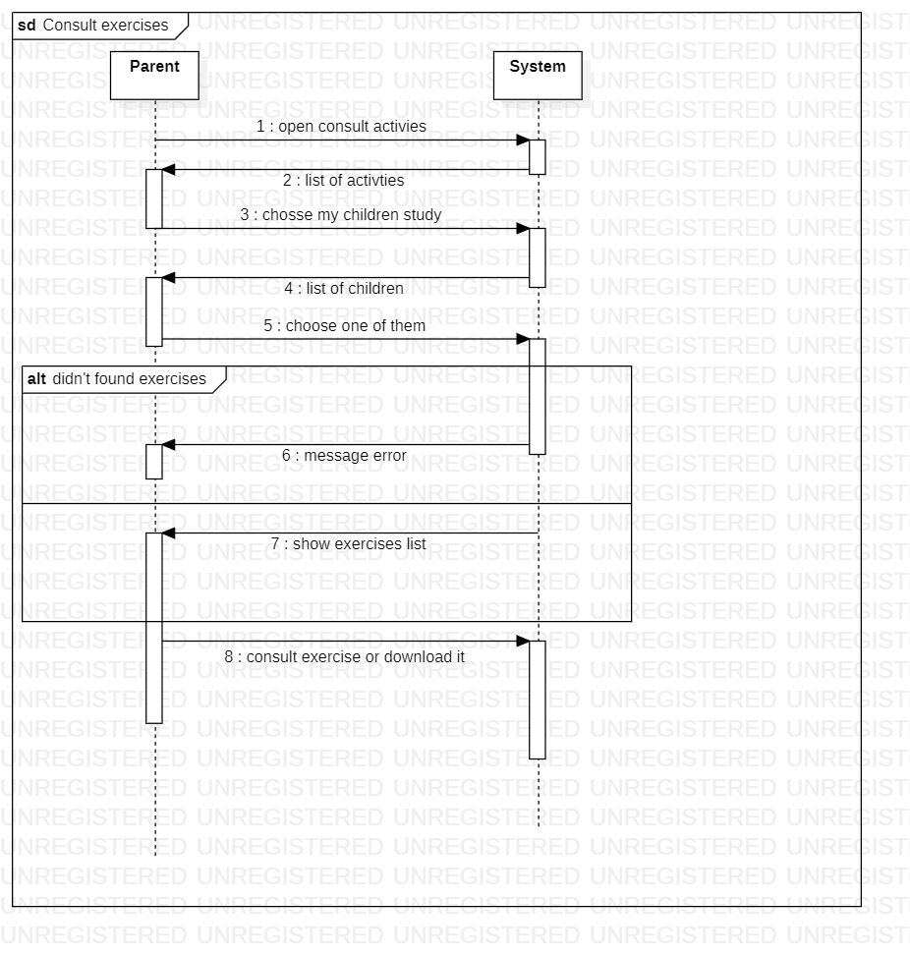

**View how many time children is absent**

| **Case name** | View how many time children is absent |
| --- | --- |
| **type** | Principal |
| **actors** | Parent |
| **objective** | view the absences of my children and justify it |
| **pre-condition** | Sign-in and add children |
| **nominal scenario** | * Go to “Consult activities” * Choose “my children absences” * The system displays list of children * The parent choose one of them * The system displays list of absences and their dates * The parent can exit or choose an absence * The system displays more information about absence * The parent justify it and he can upload a pdf or picture of justification |
| **alternative scenarios** |  |
| **exception scenarios** | The parent upload something other than a picture or a pdf(video or program ….) |
| **post-condition** | Justify the absences |



**Add student and children to the system**

| **Case name** | Add student and children to the system |
| --- | --- |
| **type** | Principal |
| **actors** | School administration |
| **objective** | Add new person to the system of school |
| **pre-condition** | Sign in |
| **nominal scenario** | * The actor choose “Add student and children to the system” * The system displays 2 buttons , teacher and student * The actor choose one of them * The system display a form of information * The actor fills the form * The system display a form of classes * The actor fills out the form and save * The system save the new person |
| **alternative scenarios** |  |
| **exception scenarios** | 1. The person is exist on the system |
| **post-condition** | A new person saves on the system |



**Add points sheets and school documents**

| Name | Add points sheets and school documents |
| --- | --- |
| Principal auteur | Administrator |
| Secondary auteur | None |
| objective | Allows the administrator to add points sheets to the system |
| Precondition | Consult the list of students, have the points and authenticate |
| Nominal scenario | * the admin login in the system. * the system verify the information. * the admin choose the ... * the system shows the year of studying. * the system asks the admin to choose the year. * the system shows the classes . * the system asks the admin to choose the class. * the system shows the list of students. * the system asks the admin to choose the student. * the system asks the admin to add the points. * the system sends the point sheet. |
| The repetitive scenario | A1) System can’t found the student  -System noted that the student doesn’t exist in the data base |
| Exception scenario | SE1 : starts from the point 10  11-the student no longer exists  12 -The system asks to delete the student |
| postcondition | The points has been added |

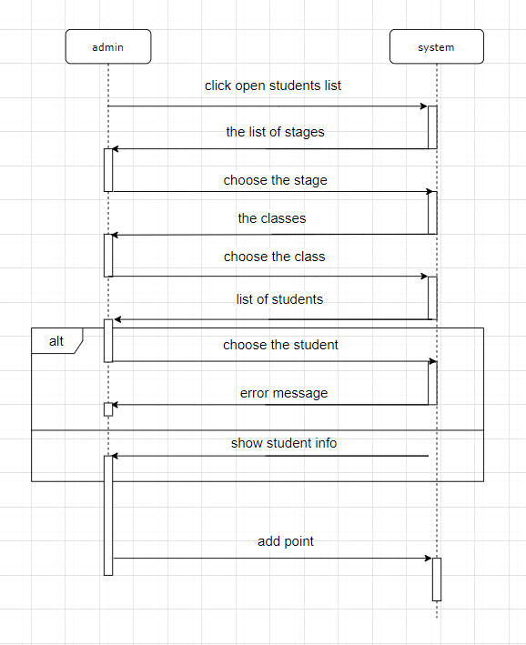

**Contact and chat with teachers**

| Name | Contact and chat with teachers |
| --- | --- |
| Principal auteur | The parent |
| Secondary auteur | none |
| objective | Allows the parent to have ability to contact with any teacher he wants |
| Precondition | The parent has to consult the list of teachers . The list appeared |
| Nominal scenario | * The parent choose the teacher * System drive him to the chat box * The system asks to type the message * The parent type the message * The system asks to send it * The parent click the send button * The system notify the teacher * The system displays a message says ‘your message has been sent and the teacher will respond before 48 hours |
| The repetitive scenario |  |
| Exception scenario | SE1 : starts from the point 5  The parent decides to not send the message  6- the parent click on the cancel button  7-the system returns him to the home page  SE2 : The system notify the parent that his message didn’t send  8 – the system display a message says ‘ your message didn’t send wait and retry’ |
| Postcondition | The message passed on the system  The teacher has been notified |

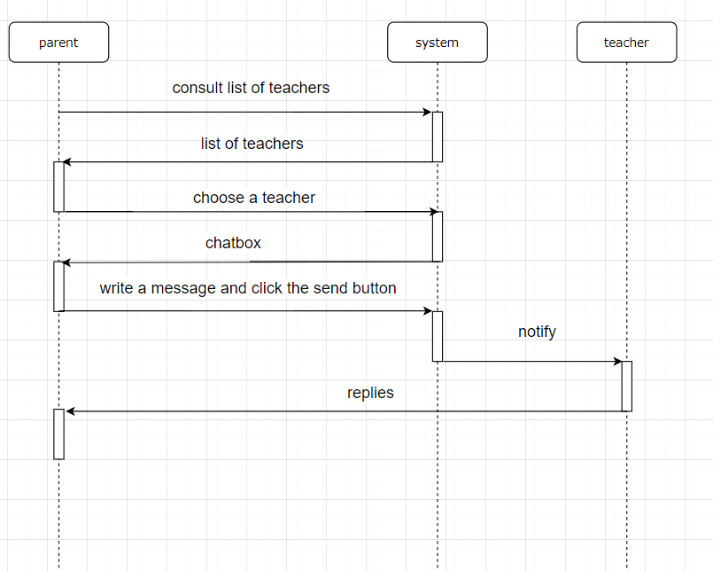

**Diagramme d’activite :**

